下载
git clone 地址
上传
cd 上传文件夹/
git add .
git commit -m "摘要"
git push origin master
接下来输入用户名和密码

- 在指定目录中空白处，点击鼠标右键,点击git bash here 选项
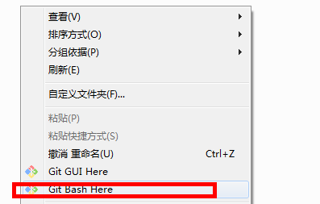
- 弹出黑色类似控制台的窗口、
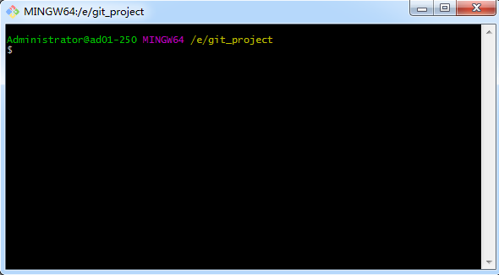
- 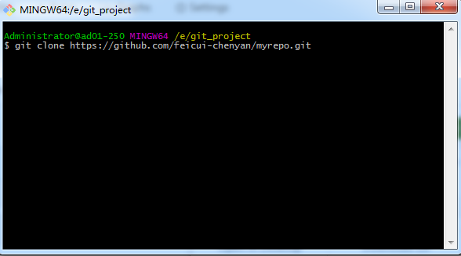
- 点击回车后，开始执行
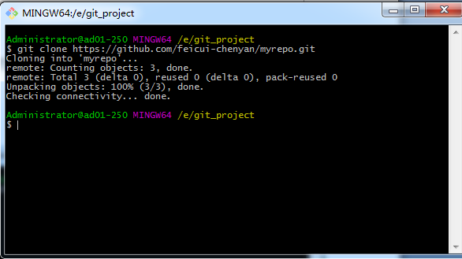
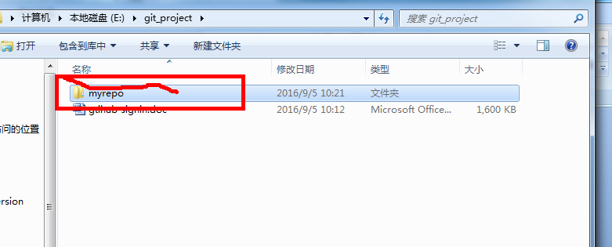

- 现在把一个doc文档放到myrepo文件夹中、
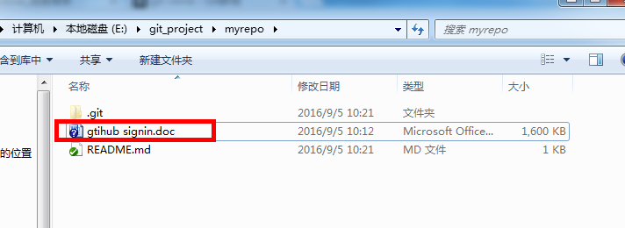
- 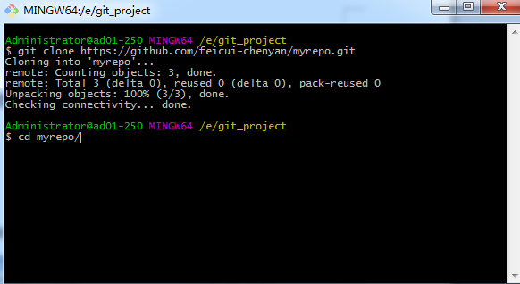
- 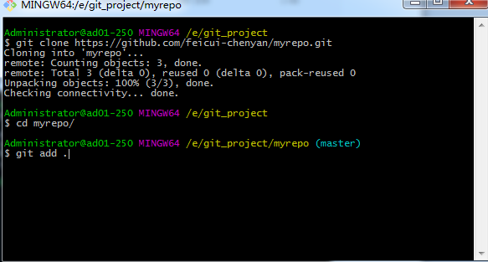
- 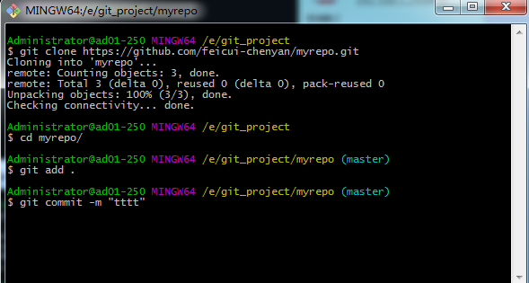
- 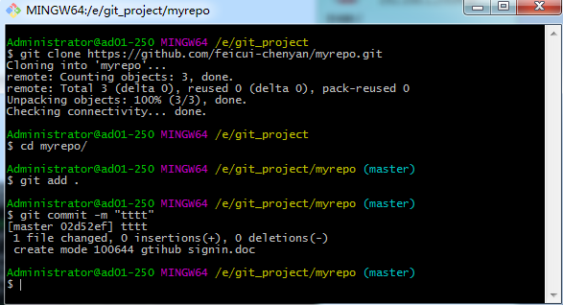
- 出现图中的原因是由于没有配置git的publik key造成、
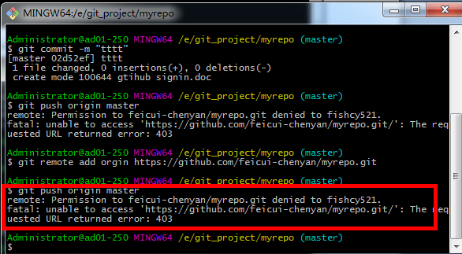
- 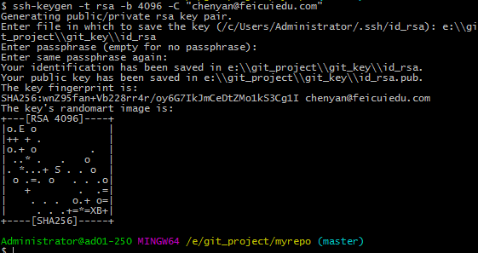
- 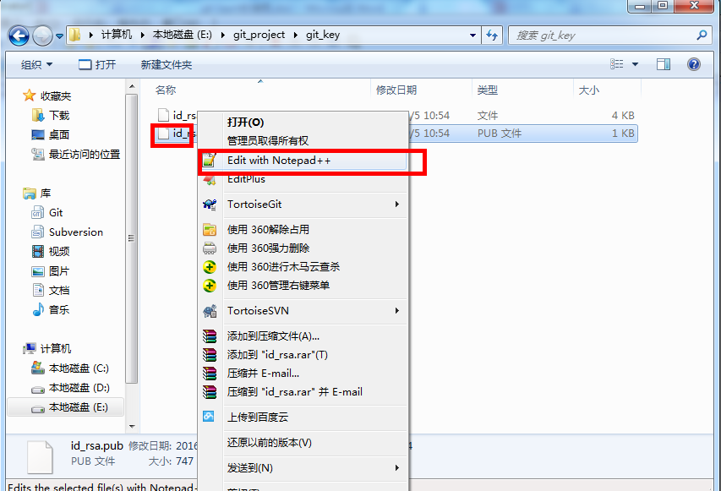
- 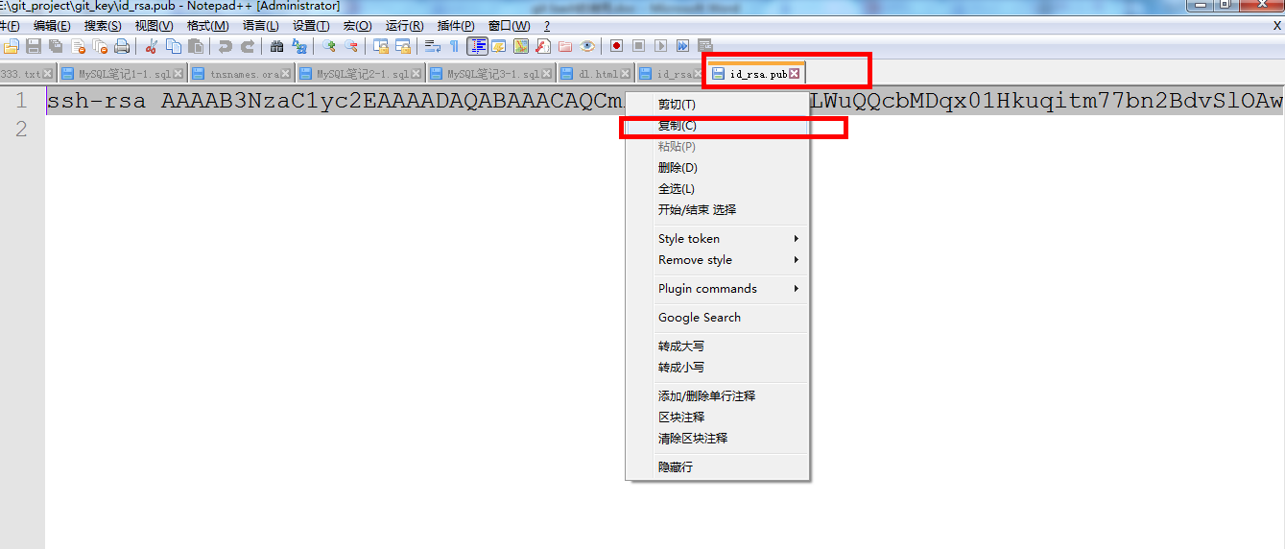
- 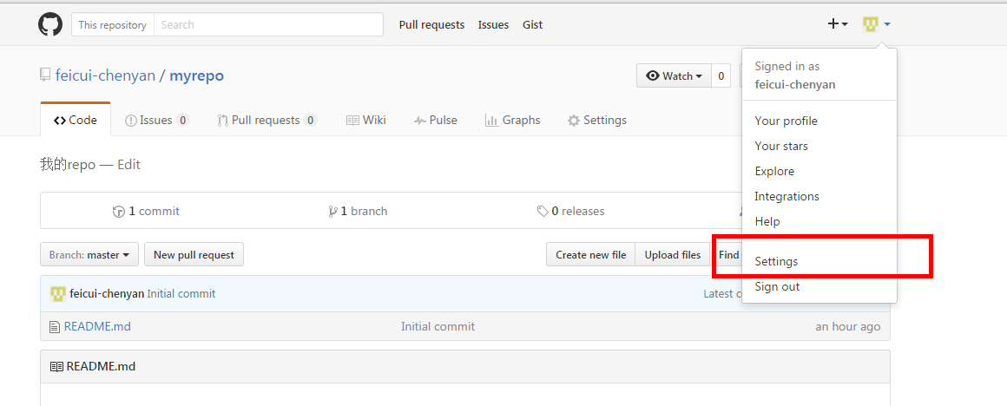
- 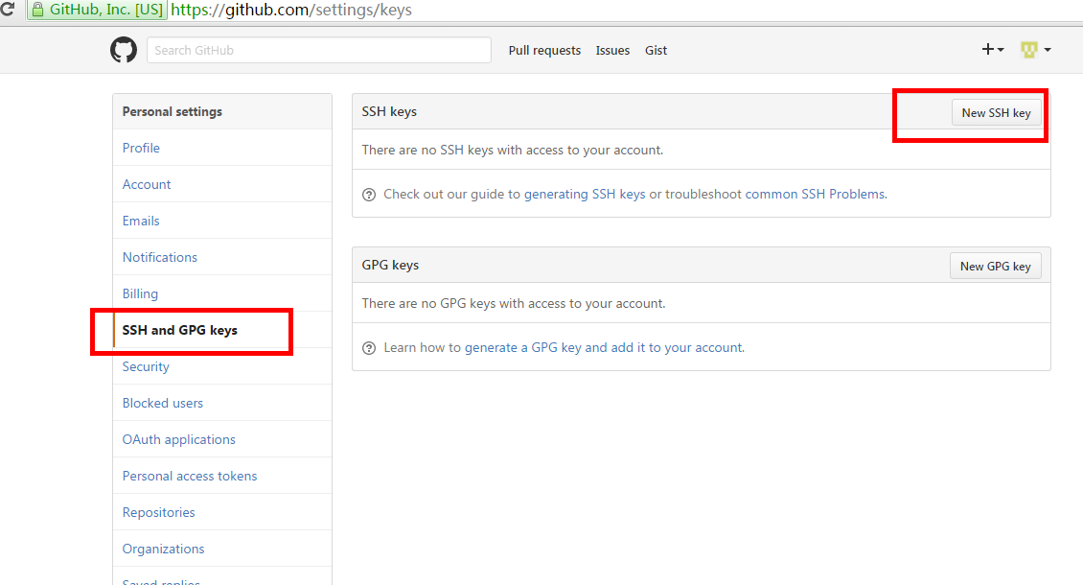
- Title 随意输入,把从rd_rsa中复制出来的内容贴到 key中去，然后点击add ssh key
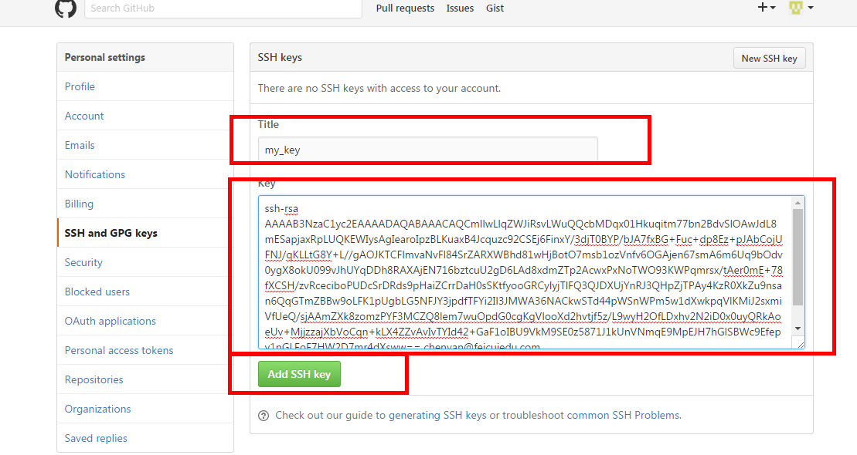
- 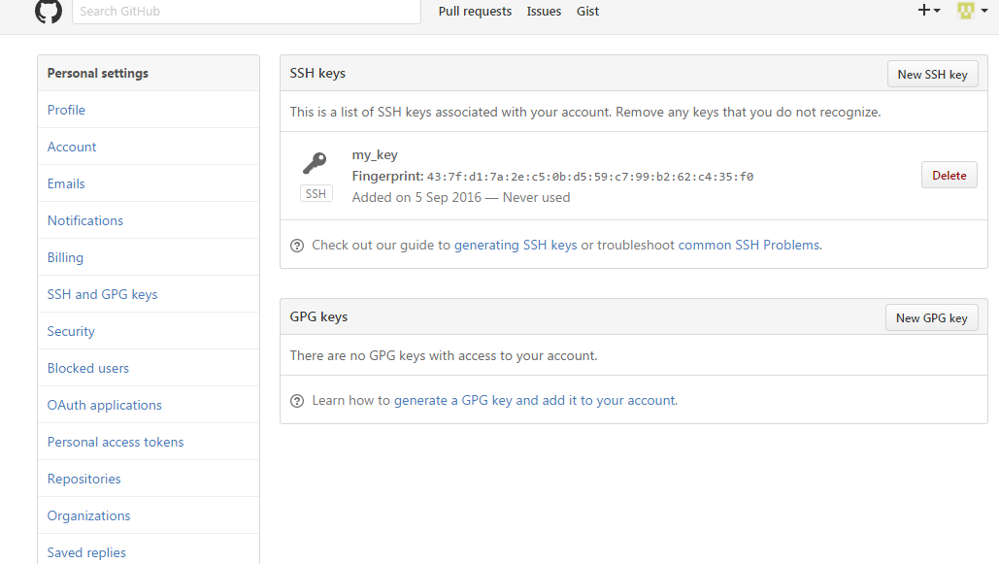
- Administrator@ad01-250 MINGW64 /e/git_project/myrepo (master)
- $ exec ssh-agent bash

- Administrator@ad01-250 MINGW64 /e/git_project/myrepo (master)
- $ eval ssh-agent -s
- SSH_AUTH_SOCK=/tmp/ssh-Ec1Als57uFVn/agent.11916; export SSH_AUTH_SOCK;
- SSH_AGENT_PID=11184; export SSH_AGENT_PID;
- echo Agent pid 11184;

- Administrator@ad01-250 MINGW64 /e/git_project/myrepo (master)
- $ ssh-add "e:\git_project\git_key\id_rsa"
- Enter passphrase for e:\git_project\git_key\id_rsa:
- Identity added: e:\git_project\git_key\id_rsa (e:\git_project\git_key\id_rsa)

- Administrator@ad01-250 MINGW64 /e/git_project/myrepo (master)
- $ ssh -vT git@github.com
- OpenSSH_7.1p2, OpenSSL 1.0.2h 3 May 2016
- debug1: Reading configuration data /etc/ssh/ssh_config
- debug1: Connecting to github.com [192.30.253.113] port 22.
- debug1: Connection established.
- debug1: key_load_public: No such file or directory
- debug1: identity file /c/Users/Administrator/.ssh/id_rsa type -1
- debug1: key_load_public: No such file or directory
- debug1: identity file /c/Users/Administrator/.ssh/id_rsa-cert type -1
- debug1: key_load_public: No such file or directory
- debug1: identity file /c/Users/Administrator/.ssh/id_dsa type -1
- debug1: key_load_public: No such file or directory
- debug1: identity file /c/Users/Administrator/.ssh/id_dsa-cert type -1
- debug1: key_load_public: No such file or directory
- debug1: identity file /c/Users/Administrator/.ssh/id_ecdsa type -1
- debug1: key_load_public: No such file or directory
- debug1: identity file /c/Users/Administrator/.ssh/id_ecdsa-cert type -1
- debug1: key_load_public: No such file or directory
- debug1: identity file /c/Users/Administrator/.ssh/id_ed25519 type -1
- debug1: key_load_public: No such file or directory
- debug1: identity file /c/Users/Administrator/.ssh/id_ed25519-cert type -1
- debug1: Enabling compatibility mode for protocol 2.0
- debug1: Local version string SSH-2.0-OpenSSH_7.1
- debug1: Remote protocol version 2.0, remote software version libssh-0.7.0
- debug1: no match: libssh-0.7.0
- debug1: Authenticating to github.com:22 as 'git'
- debug1: SSH2_MSG_KEXINIT sent
- debug1: SSH2_MSG_KEXINIT received
- debug1: kex: server->client chacha20-poly1305@openssh.com <implicit> none
- debug1: kex: client->server chacha20-poly1305@openssh.com <implicit> none
- debug1: expecting SSH2_MSG_KEX_ECDH_REPLY
- debug1: Server host key: ssh-rsa SHA256:nThbg6kXUpJWGl7E1IGOCspRomTxdCARLviKw6E5SY8
- debug1: Host 'github.com' is known and matches the RSA host key.
- debug1: Found key in /c/Users/Administrator/.ssh/known_hosts:1
- debug1: SSH2_MSG_NEWKEYS sent
- debug1: expecting SSH2_MSG_NEWKEYS
- debug1: SSH2_MSG_NEWKEYS received
- debug1: SSH2_MSG_SERVICE_REQUEST sent
- debug1: SSH2_MSG_SERVICE_ACCEPT received
- debug1: Authentications that can continue: publickey
- debug1: Next authentication method: publickey
- debug1: Offering RSA public key: e:\\git_project\\git_key\\id_rsa
- debug1: Server accepts key: pkalg ssh-rsa blen 535
- debug1: Authentication succeeded (publickey).
- Authenticated to github.com ([192.30.253.113]:22).
- debug1: channel 0: new [client-session]
- debug1: Entering interactive session.
- debug1: client_input_channel_req: channel 0 rtype exit-status reply 0
- Hi feicui-chenyan! You've successfully authenticated, but GitHub does not provide shell access.
- debug1: channel 0: free: client-session, nchannels 1
- Transferred: sent 3848, received 2040 bytes, in 0.6 seconds
- Bytes per second: sent 6743.8, received 3575.2
- debug1: Exit status 1

